Static Culling Custom targets

For StaticCulling, you can specify any objects to cull, and you can specify any behavior for them.

This scene prompts you to set up culling for Particle System and Spot Light.

To configure CullingTarget you need to do the following steps :
- Attach the StaticCullingSource component to this object and select SourceType : Custom.
- Set the boundaries of this object.

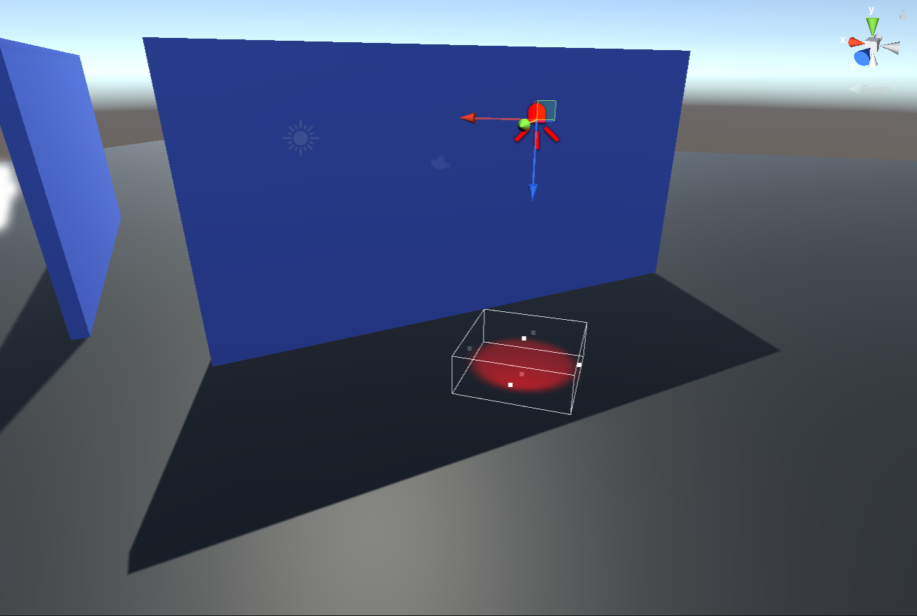
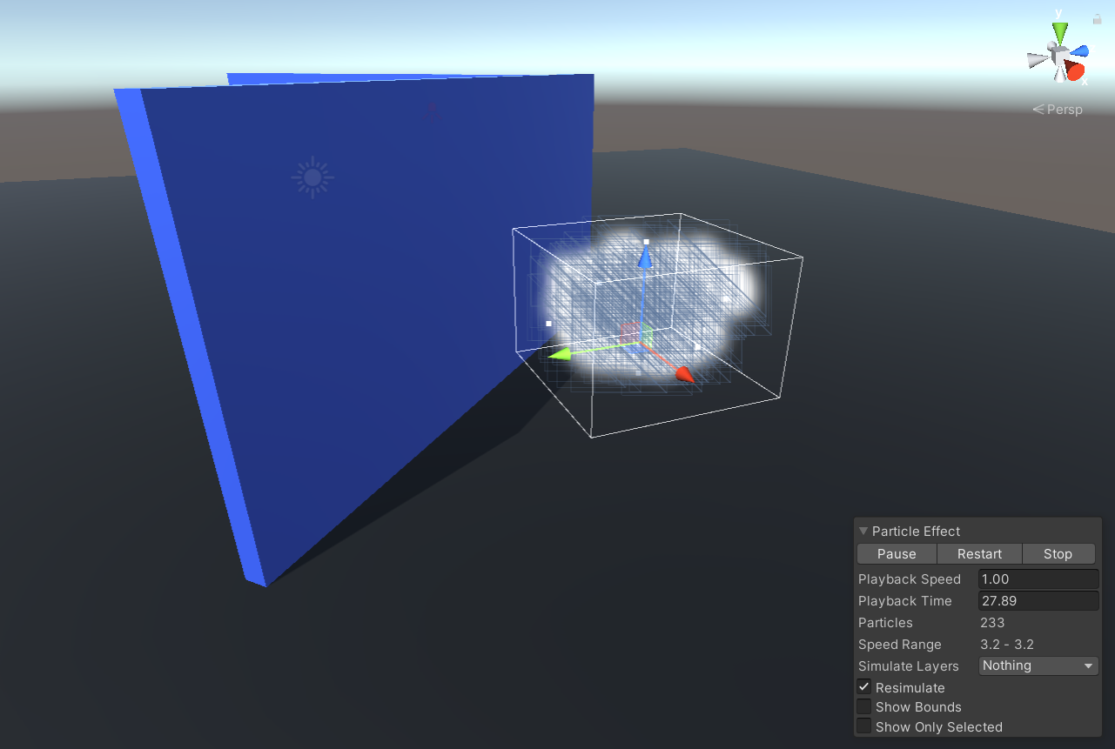

- Set the actions to be called when the object is visible or not visible.

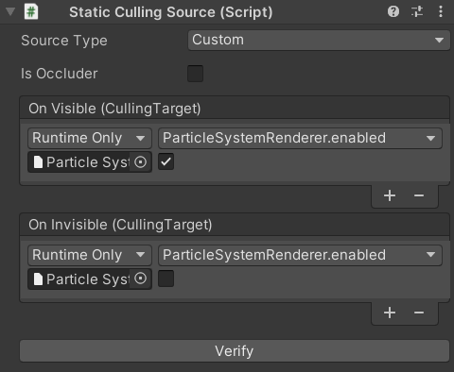

- If the object can overlap other objects - enable isOccluder and use colliders to set overlapping boundaries.

Bake scene and look at results.

